Step 1: Deploy the Contract.

Link of transaction for deployment : <https://ropsten.etherscan.io/tx/0xd3fa4f7b0f4297148351eae62ce378c921e756c76bf30c54781c76d1bd2b5ca1>

Contract id : 0x520CFBab9681651Ba0727513C60c89c39D604aEb

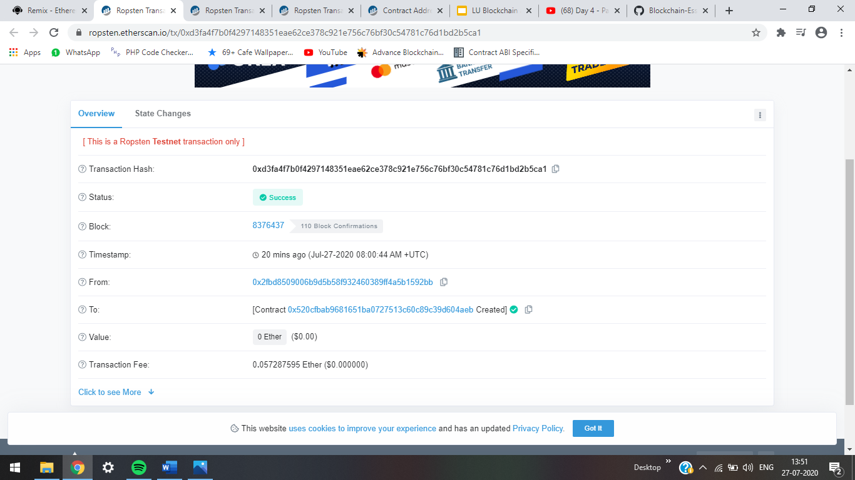

Step-2 : Storing the data.

Link of transaction :

<https://ropsten.etherscan.io/tx/0xad85d3dd0af0369b302ea4c706fed679f93783ab055e53fde2885a640848e967>

contract ID : 0x520CFBab9681651Ba0727513C60c89c39D604aEb 